wysall and Thorpe in the
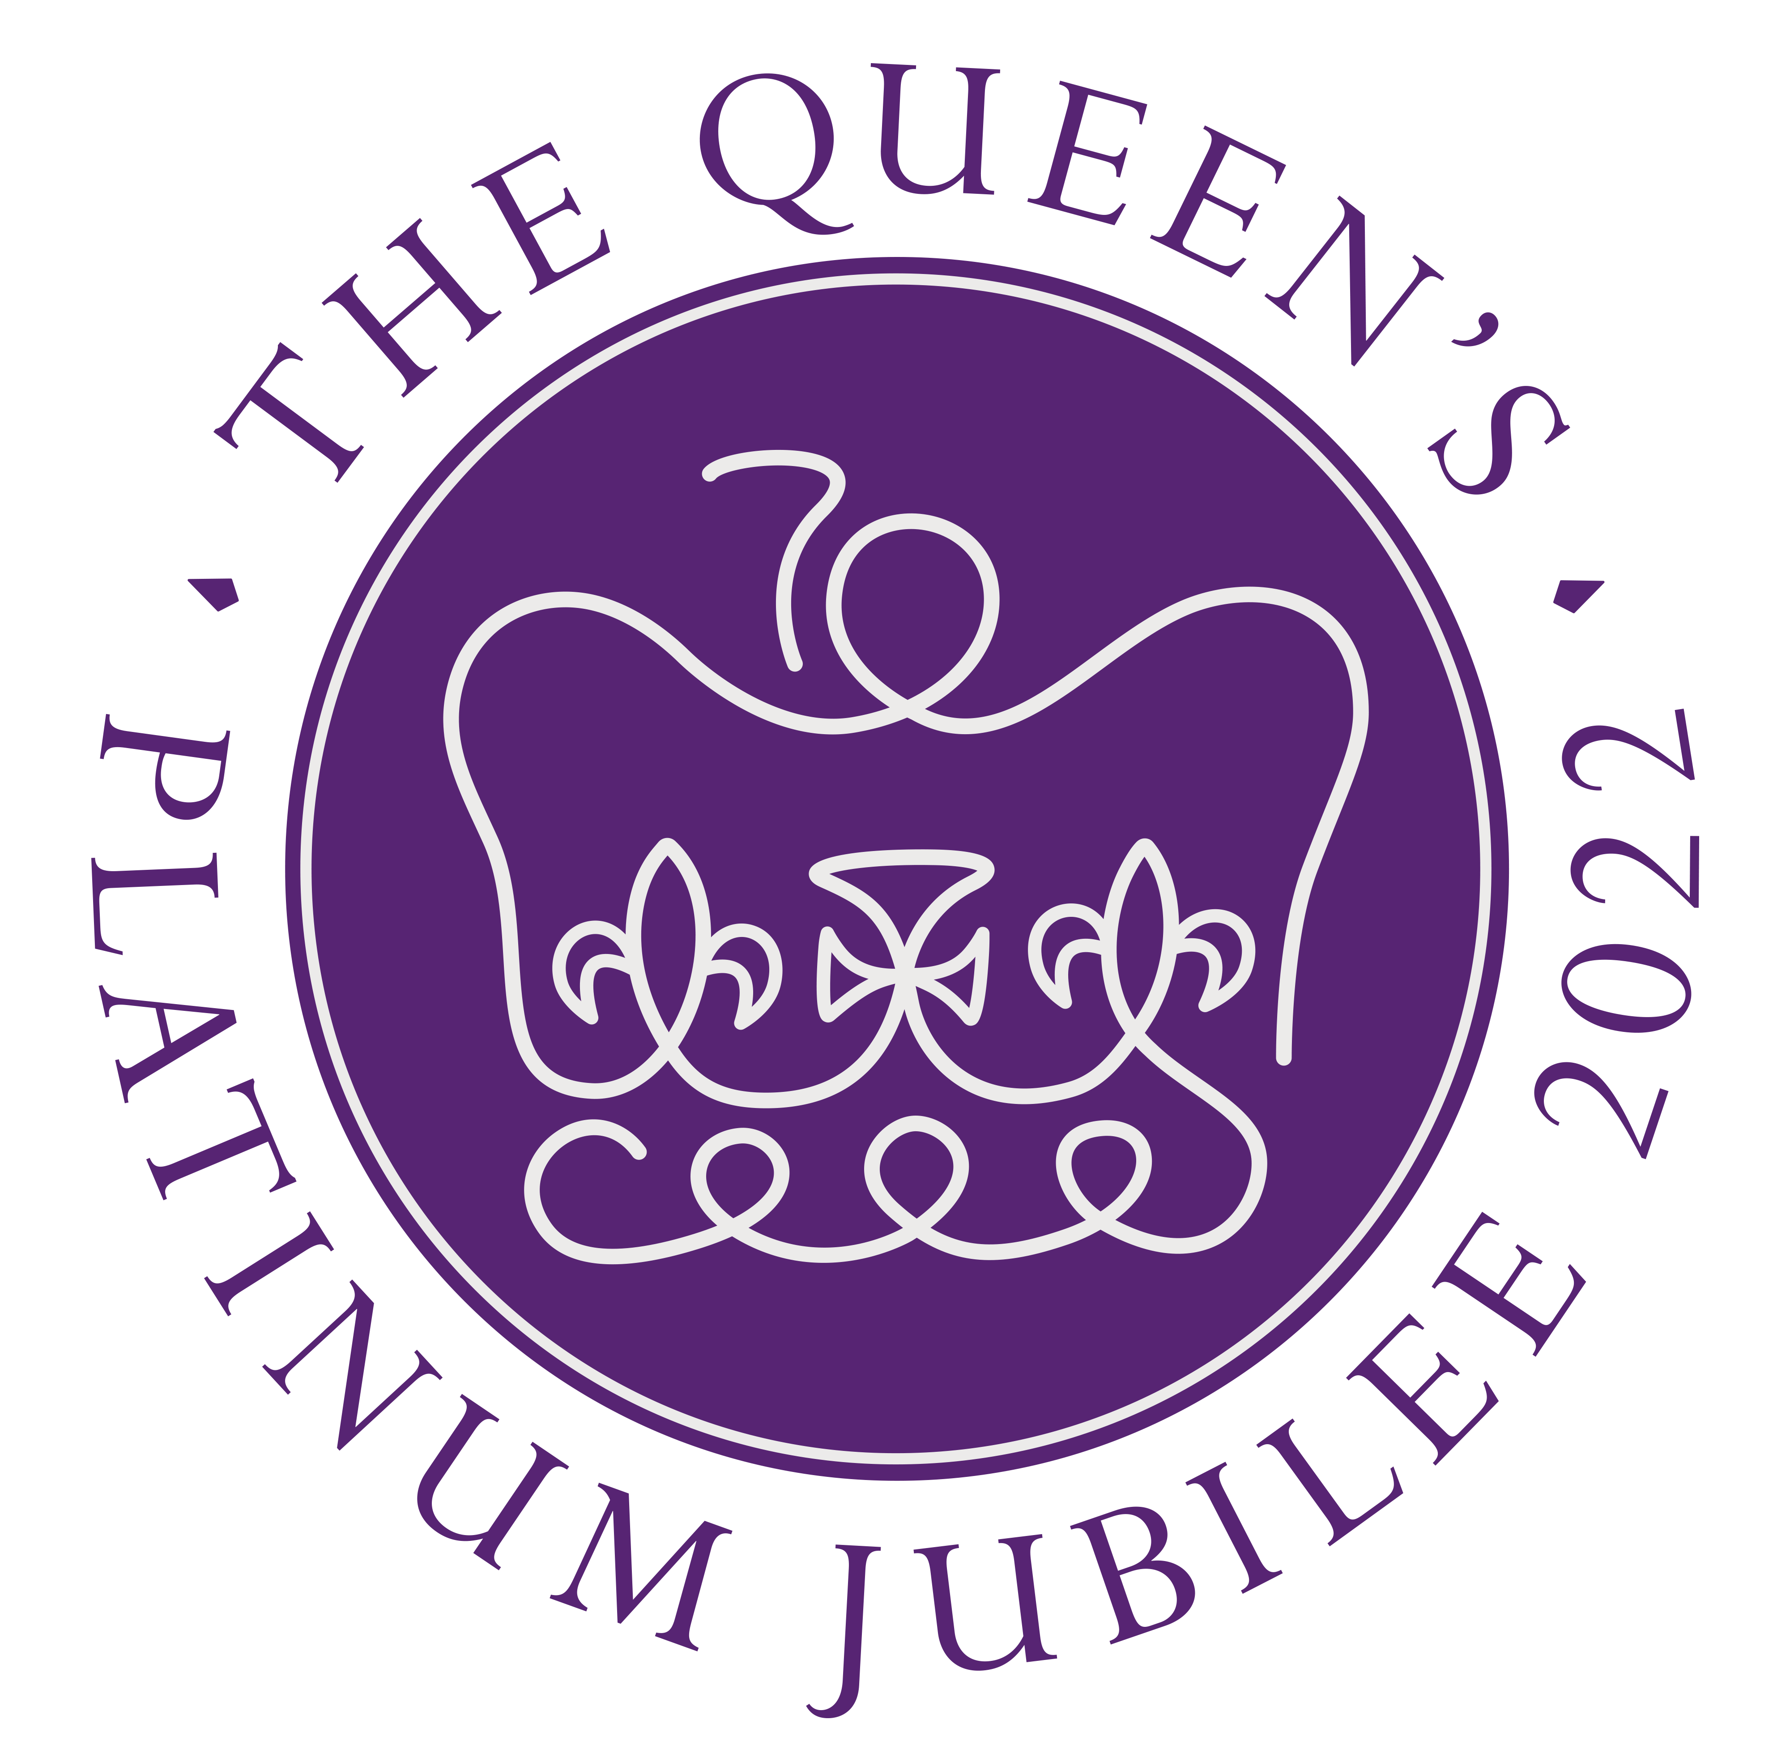
June 2,3,4,5

glebe Parish Council
(Rushcliffe Borough Council, Nottinghamshire)

19/21 Main Street
Keyworth
Notts
NG12 5AA

Clerk to the Council:
MIKE ELLIOTT
Tel: 0115 937 6506
Email clerk@wysall.parish.email

The next meeting of the parish council will be held on Tuesday, January 11, 2022 at 7.15pm prompt and be held in the Village Hall, Wysall. Members and Visitors are reminded they should wear masks to attend the meeting which will be held with social distancing in place. Masks may be removed but only when seated. Members of the public are welcome to attend to listen to the proceedings but there will be no public participation item.

The agenda is:
1] Apologies
2] Minutes from Previous Meeting held on December 7, 2021
3] Declarations of Interest
4] Precept and Budget 2022-2023 and accounts to pay
5] Clerks Report
6] Report from the District and County Council Member
7] Village Hall Update on lighting project, Landscaping.
8] Playground equipment project, planning and funding application)
9] Traffic – Accident update.
10] Correspondence
11] Planning
12] Environment
13] HM Queen 70th year Reign June 2,3,4 and 5, 2022.
14] Next meeting February 1, 2022

Mike Elliott
Clerk

